Lab 3: Energy Measurement Using PMT

Lily Bechtel, Diego, Dan

University of Washington

October 26, 2017; November 11, 2017

Statement of Purpose

The purpose of this lab was to explore the uses of light pulsers, compare plastic and NaI scintillators and photomultiplier tubes, and to gain familiarity with taking pulse height measurements. We primarily are using techniques learned in previous labs to accomplish these tasks. The radioactive sources used this week are 137Cs, 60Co, 133Ba, and 22Na. Our goal is to compare the pulse height spectra for these sources for the plastic and NaI scintillator detectors.

Theory

Radioactive Decays for Gamma Detection

137Cs 🡪 e- + + 137Ba

137Cs has a half-life of approximately 30 years. It decays through ß- into 137Ba\*, then the excited barium will decay into 137Ba and release a gamma of energy 0.66MeV. This is the gamma we will detect to make pulse height measurements. Cesium is frequently used for calibrating instruments for nuclear decay detection.

60Co 🡪 e- + + 60Ni

60Co has a half-life of about 5.3 years and also undergoes beta decay. The nickel originally decays into is doubly excited and will decay twice into its stable state. Each time it decays it will release a gamma, with energies 1.17MeV and 1.33MeV. Cobalt decay is historically important due to its involvement with nuclear weapons, and the its use in early radioactive cancer treatment.

133Ba +e- 🡪 + 133Cs

133Ba has a half-life of about 10 years, and decays through electron capture. It decays into excited states of cesium, and as cesium decays into its stable form, it will release gammas of energy 437 keV and 383 keV.

22Na 🡪 22Ne + e+ + e; e+ + e- 🡪

22Na has a half-life of about 2.6 years, and decays through beta plus decay. It initially decays into an excited state of neon, and then neon decays into a stable state, releasing a gamma of 1275 keV. The positron will annihilate with surrounding matter, producing two photons, each equal to the energy of the rest mass of the electron, 0.511 MeV.

Plastic vs. NaI Scintillators

Plastic scintillators are made from polymer plastics, and are generally less expensive than other scintillator types. It also allows them to be shaped into molds for specific shapes and purposes. They have fast signals and a high light output. NaI scintillators are a type of inorganic crystal scintillators. The NaI is typically doped with thallium, and has a scintillation color of blue. Inorganic crystal scintillators can be made more sensitive to positron decay because they can be cut and arranged in different ways than a plastic detector. However, NaI detectors are typically more expensive, and have a slower signal time. Since we will be using both in this lab, we will keep in mind these differences to get accurate readings.

Apparatus

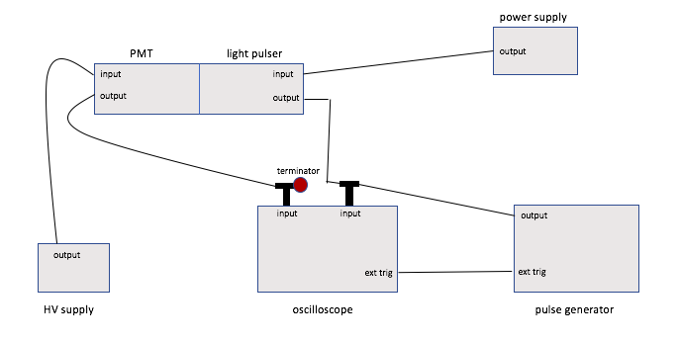

Figure 1: apparatus for “Photomultiplier Response.” Using BNC 8010 NIM pulse generator, 50Ω terminator, 10 stage Electron Tubes 9266KB PMT, light pulser, Stanford model P325 high voltage supply, and Harrison 6289A power supply.

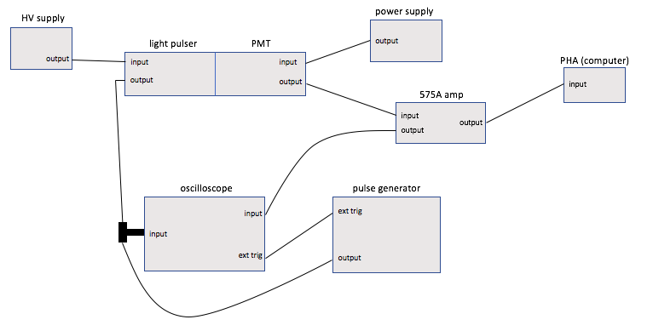

Figure 2: second apparatus for “Photomultiplier Response.” Adding the Ortec 575A pulse-shaping amplifier, and the Pulse Height Analyzer program on the computer.

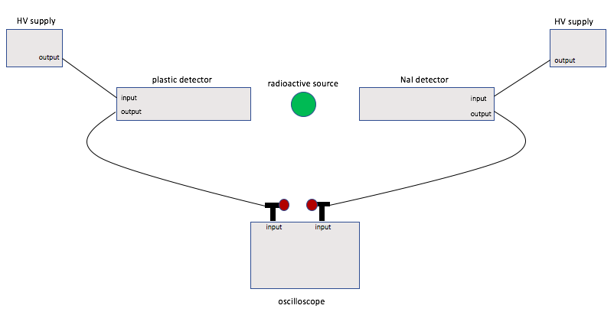

Figure 3: apparatus for “Comparison of Plastic and NaI.” Using the plastic scintillator with PMT, and the NaI crystal with its PM, along with a second high voltage supply.

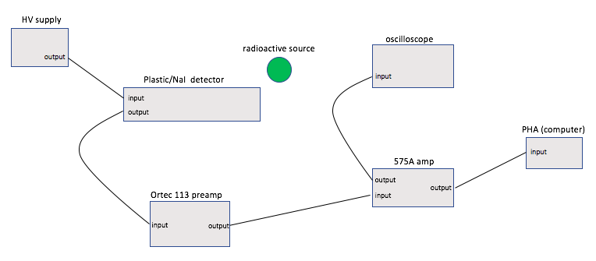

Figure 4: apparatus for “Pulse Height Spectra.” Using the same equipment as previous apparatus, rearranged for pulse height measurements.

Procedures

Photomultiplier Response

To make sure we are using appropriate pulses for the light pulser, we initially connect the output of the pulse generator to the input of the oscilloscope, then terminate this signal with 50Ω to avoid reflection. We also use the pulse generator to trigger on our pulse by using the external trigger on the scope. We set the pulse width to 30ns, pulse height to 4V, and a pulse period to 20µs (as seen in data fig. 1).

Connecting the light pulser to its power supply (Harrison), and setting the voltage to 25V, we observe the small green LED light is lit by looking into the tube. With this verified, we tape the light pulser tube into the photomultiplier using black electrical tape, assuring there are no light leaks.

Arranging equipment into the apparatus in figure 1, we can now observe the PMT. To find the noise of the PMT, we disconnect the pulse generator from the scope, and turn on the voltage to 800V, triggering internally on the noise. We looked at this noise both at 800V and 900V (data figures 2a and 2b). As we increase the voltage, the amplitude of the noise increases, as does the uncertainty.

Now reconnecting the output of the pulse generator, and setting the voltage to the PMT to 850V, we see a pulse of height of about 500mV. From here we vary the following: DC voltage between 24-40V, pulse width between 30-50ns, and pulse height between 3-4V (data figure 3). Then setting the pulse width to 30µs, we vary the high voltage between 400-900V (data figure 4).

To study the fluctuation of the PM, we use apparatus figure 2. We adjust the gain on the amplifier, and change the scales on the scope to get a clear positive pulse with a height of 5V. Keeping this voltage setting, we collected data for three pulses (data figure 5).

Comparison of Plastic and NaI

Using the apparatus in figure 3, we take a quick pulse comparison from each of the scintillators by placing 137Cs between them and viewing each output on separate channels of the scope (data figure 6). It is clearly seen in this image that the time response for the NaI is much slower than the plastic.

Pulse Height Spectra

For a more comprehensive comparison of the two detectors, we will be looking at pulse height spectra for 137Cs and 60Co on both detectors, and then looking at the spectra of 133Ba and 22Na on the NaI detector. To do this we use apparatus figure 4, with the voltage set to 1000V. Then using some trial and error, we set the max pulse height from 137Cs to about 5V and collect data for cesium and cobalt on the plastic detector. Changing to the NaI detector, we use the 60Co to set the max pulse to 9V by changing the gain on the 575A, and then take spectra for 60Co, 137Cs, 133Ba, 22Na.

Data

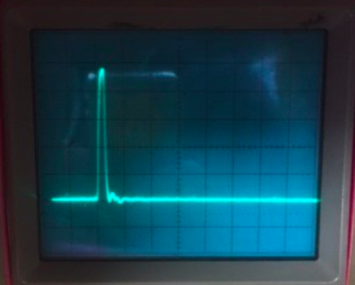

Figure 1: pulse set from pulse generator in “PM Response” (scale: 0.05µs/cm vs 1V/cm)

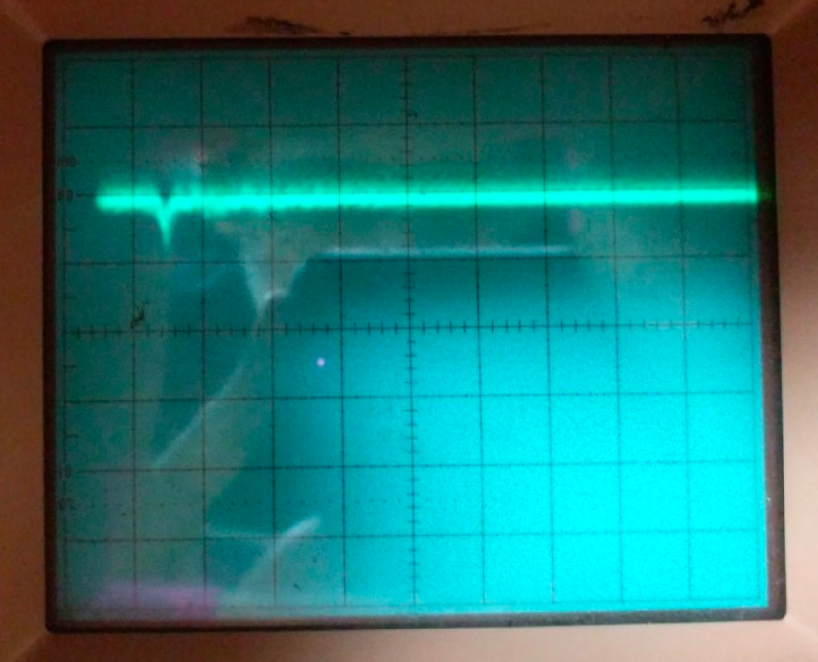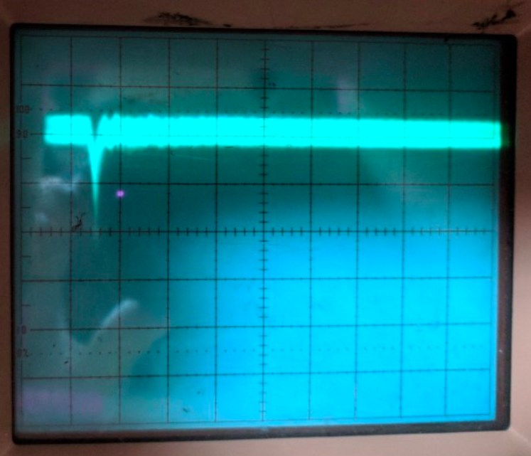

(a) (b)

Figure 2: (a) noise from PMT at 800 V, (b) noise at 900 V (scale: 0.05µs/cm vs 2mV/cm)

Figure 3: Data from varying pulse width, DC voltage, and pulse height from “PM Response”

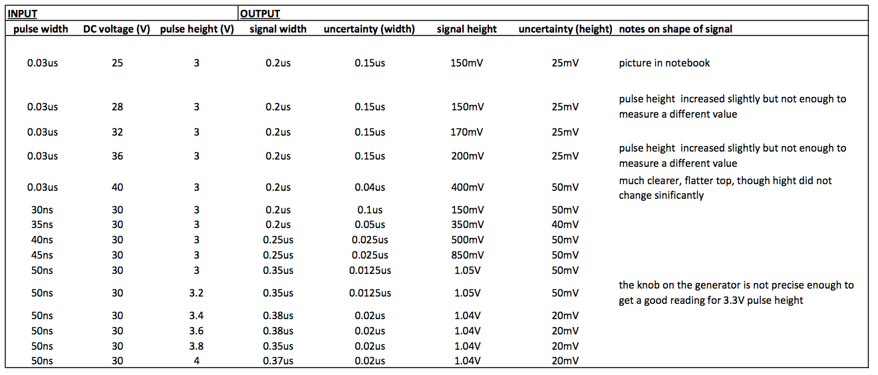

Figure 4: Data from varying high voltage in “PM Response”

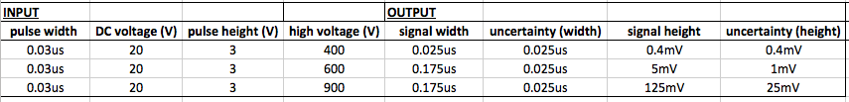

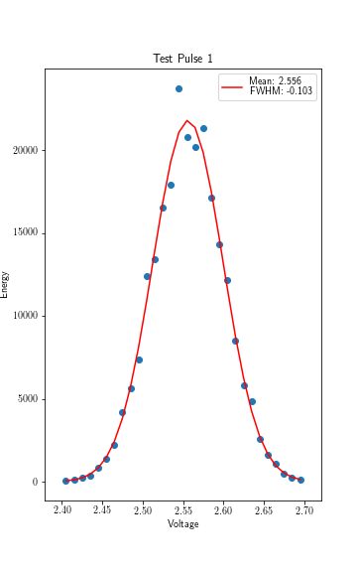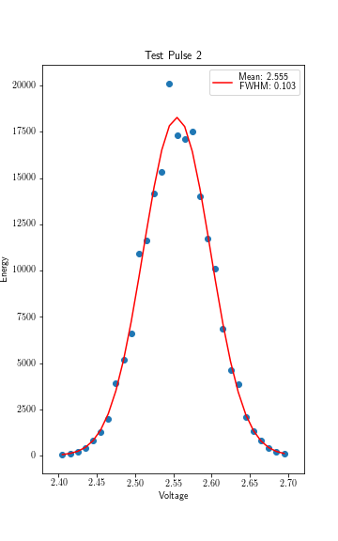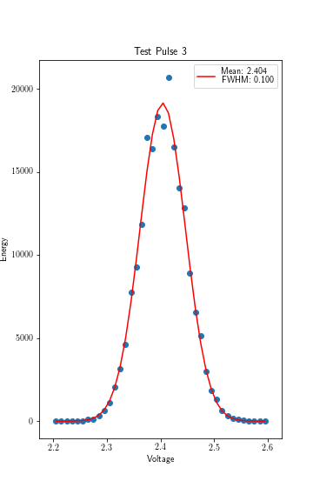

Figure 5: Data from three pulses in “PM Response” with fit Gaussian curve and full width half max.

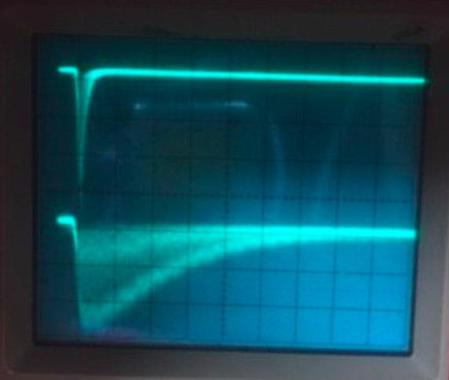

Figure 6: 137Cs pulse viewed by both the plastic scintillator (top) and the NaI scintillator (bottom), with fill width half max values of 0.01µs and 0.25µs, respectively.

Exercise 1 described in “Theory” section.

Analysis

Photomultiplier Response

As we varied the DC voltage, the only parameter of the signal that changed was the pulse height. At the lower voltages (24-32V), the height changed small amounts, if at all. The jump between 36V and 40V, however, made the signal pulse height double. We expected the uncertainty to get better as the voltage increases, because that is what we have observed with in other signals, but it did not change. The general shape changed slightly as the base of the pulse flattened out slightly with the increase of voltage.

Increasing the pulse width increased both the signal width and height noticeably. We again noticed that the higher pulse width changes resulted in bigger changes in the signal, even though we were increasing the pulse width in even increments. While uncertainty did not change much for the signal height, the signal width’s uncertainty decreased significantly with the increasing pulse width.

Varying the pulse height did not affect the signal significantly. The signal width decreased slightly, but within the original uncertainty.

Unfortunately, for us to have enough time to finish the lab, we were unable to take enough data varying the high voltage to see a clear relationship between the voltage and the signal. However, from our data we can see that increasing the voltage increases the signal width slightly, and increases the signal height significantly. We were informed that this should result in a smooth curve, but we simply do not have enough data to form this relationship.

Comparison of Plastic and NaI

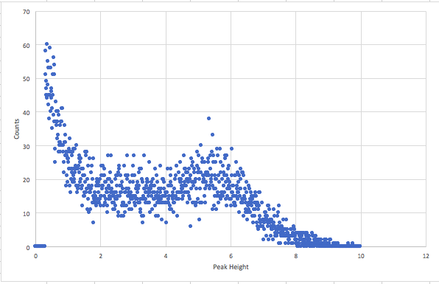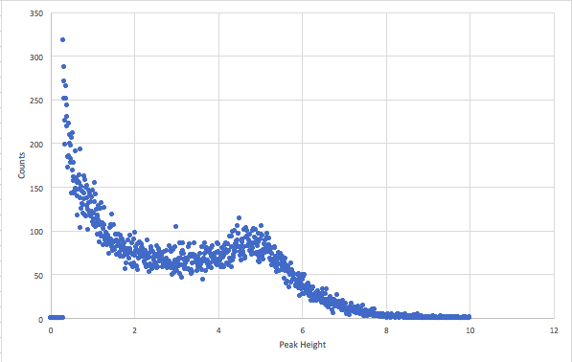

Above: plastic detector, below: NaI detector. 60Co on the left, 137Cs on the right.

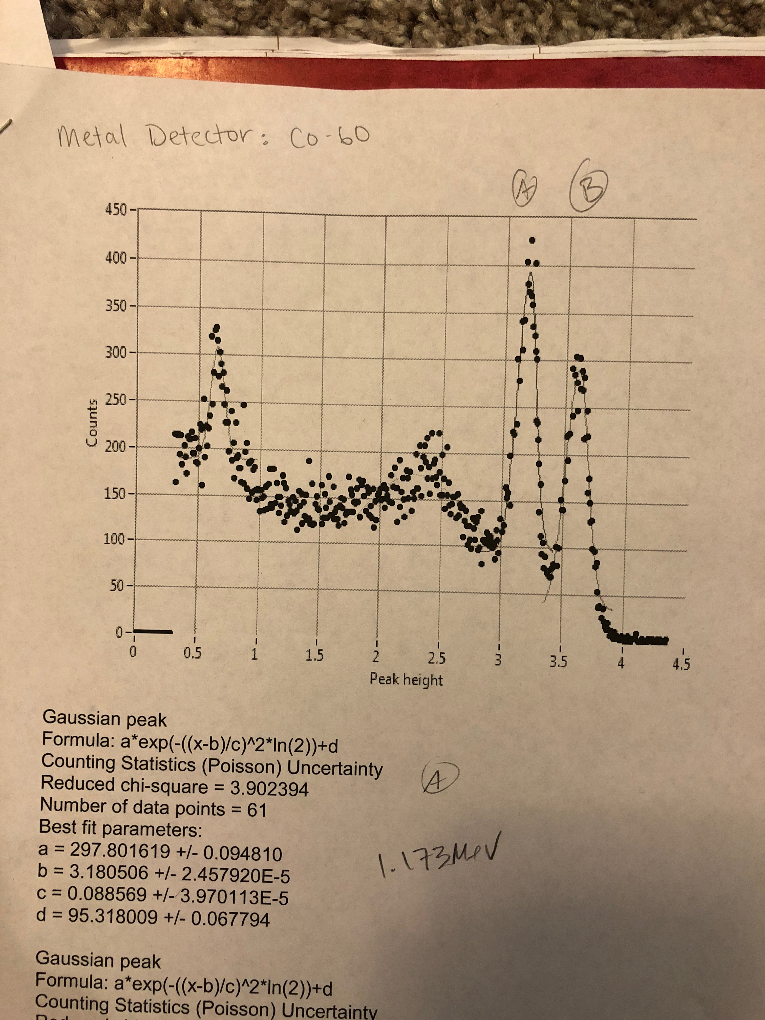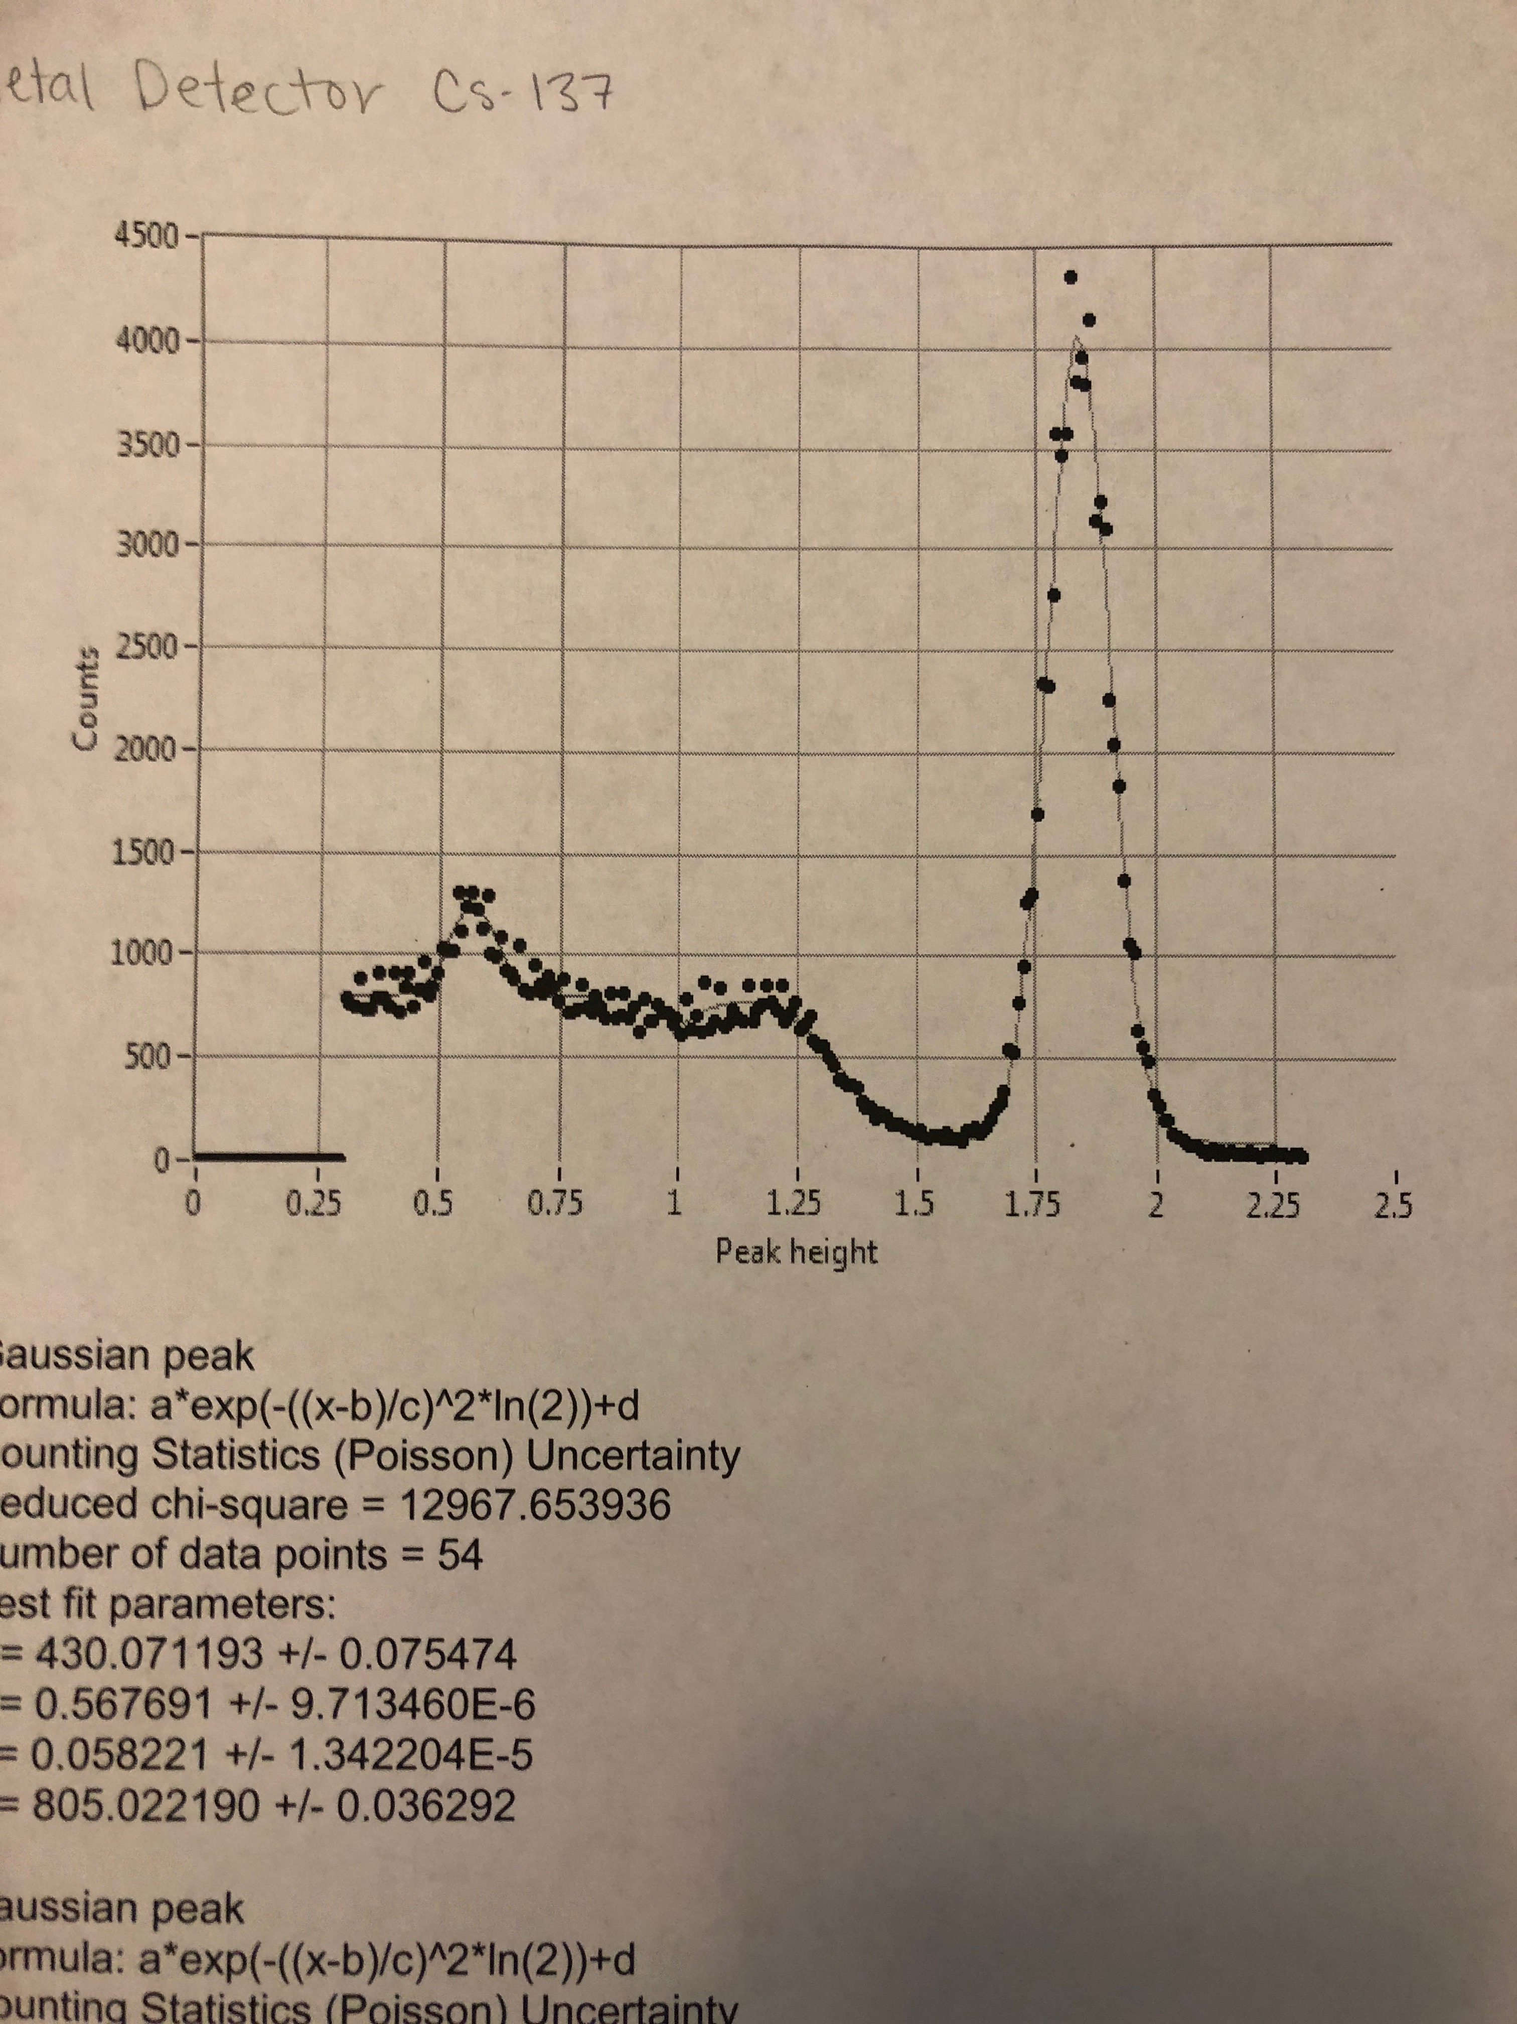

Although the only difference between these data is the instrument used to detect them, the results are very different. For 60Co, we believe that our calibration was off, and we were not able to see the two peaks from the photons. The peaks that have a similar shape and size we believe to be noise. The same thing appears to have happened for the 137Cs because the peak from the plastic detector looks very similar in shape and size to the lowest peak from the NaI detector. Since we had a similar result for both radioactive sources, this is evidence that we did our calibration incorrectly, setting the gain too low to see the higher energy photons being released.

Looking at the data from the NaI detector, we can assign the peaks to their corresponding photon energies. We do this by speculation: the highest, most prominent peaks will be from photons, and the order of energies will increase with pulse height. From this we can determine that the peak heights for 60Co are 1.17 MeV for the peak at height 3.2V, and 1.33 MeV at height 3.6V. Similarly, we can assign the peak at 1.82V for the 137Cs data, at the photon energy of 0.66MeV.

Pulse Height Spectra

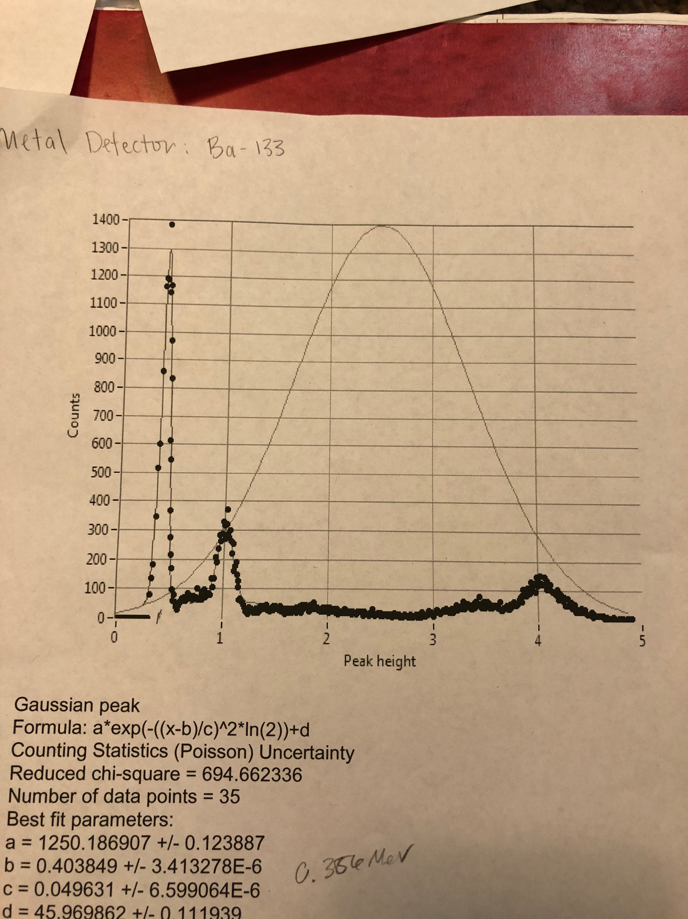 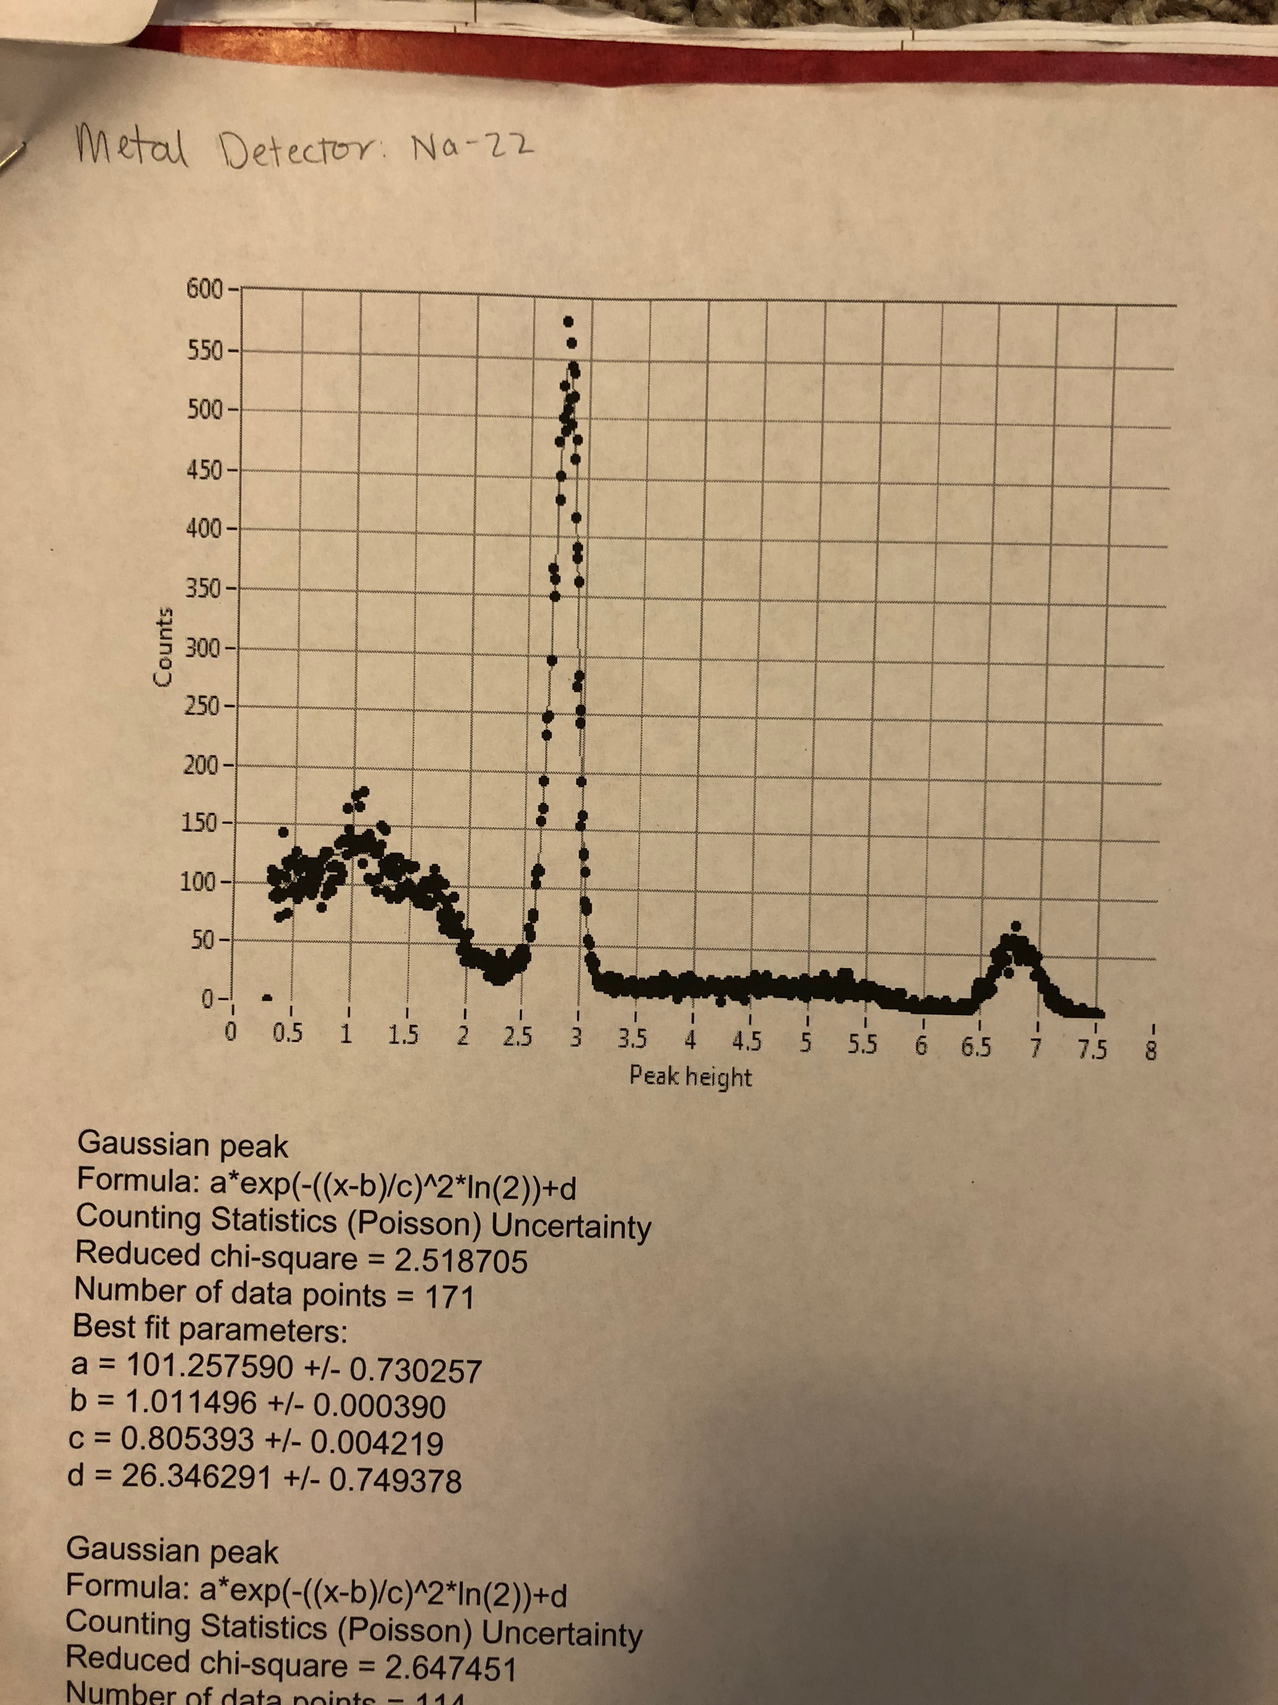

Spectra from 133Ba (left) and 22Na (right). Using the same method as above, looking at the barium spectra, we name the first two prominent peaks as the energies associated with them, 383keV and 437 keV, respectively. In the sodium, the first peak is 0.511 MeV, and the second smaller peak is 1.275 MeV. For sodium, these energies are coming from different processes, the first peak being from the positron annihilation, the second being the decay of neon. Two photons are produced in the annihilation, while only one is produced from the neon decay, which is indicated by the much higher counting of the 0.511MeV peak. In the other processes, the different number of counts per energy gives insight into the branching ratio of each decay process.

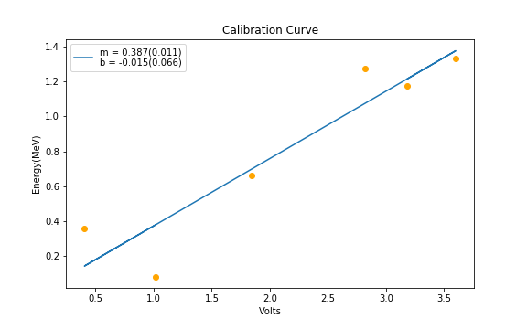

Calibration Curve: voltage vs energy, no obvious outliers.

Extra Credit

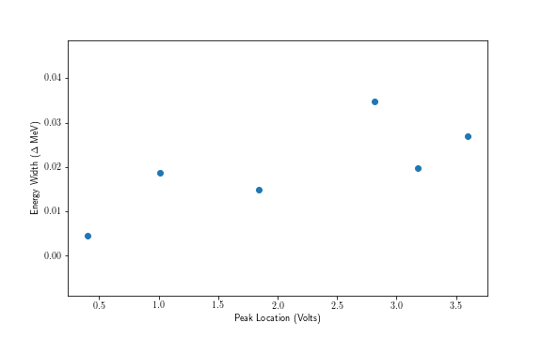

Results

Photomultiplier Response

Many of our results suggest relationships between changing parameters, although we do not have enough data to form clear pictures of the relationships. Nearly all our uncertainties lie in our ability to read the oscilloscope signals. The degree of fuzziness of the signal limits how well we can read the true value of the signal. Changing the parameters of the pulse also could change the uncertainties corresponding to the resulting signal.

Comparison of Plastic and NaI

The data we collected to compare the detectors was not ideal, and the plastic detector specifically did not accurately show the photon energies. Despite not having the proper data, we can use knowledge of the detectors to extrapolate how the spectra would differ. The differing signal response times could correlate to lower number of counts for the NaI detector; however, the NaI is more sensitive, so we might be able to see a sharper peak at each photon energy.

Pulse Height Spectra

The data we received from the NaI detector was fit with Gaussian curves, as seen in the analysis section. These curves fit our data very well, without any significant outliers. This indicates the degree of accuracy from a NaI crystal scintillator.

Discussions

Although we were not able to take the adequate number of data for a couple parts, we completed every section of the lab, and accomplished our initial goals. Using the Pulse Height Analyzer, we could see the necessity of calibration, and the importance of fitting data right away. These are skills we could apply to the next lab to avoid the same mistakes. We practiced finding uncertainties, and used these uncertainties to analyze data. Beyond this, we became familiar with new equipment, such as light pulsers, and practiced safely working with radioactive sources.

References

Leo, William R. (1994). Techniques for Nuclear and Particle Physics Experiments (2nd ed.). Springer. ISBN 978-3540572800.